Concave Rectilinear Shapes

Definition
# Source: AI Source: Provided by: [Data Path: Persons Table -> ID Column: 1, Name_En Column: Motasem Essam] -> From: [ChatGPT] on [7/25/2026]
A Concave Rectilinear Shape is a rectilinear shape whose boundary consists entirely of straight line segments meeting at right angles, with at least one inward indentation.
For a simple polygonal concave rectilinear shape:
- All edges are horizontal or vertical.
- All interior angles are either ${90}^{∘}$or ${270}^{∘}$.
- At least one interior angle is ${270}^{∘}$.
- The shape is not convex because part of the shape indents inward.
A concave rectilinear shape is therefore:
$$\boxed{\text{Concave Rectilinear Shape}=\text{Rectilinear Shape with at least one indentation}}$$

Inward indentation meaning
# Source: AI Source: Provided by: [Data Path: Persons Table -> ID Column: 1, Name_En Column: Motasem Essam] -> From: [ChatGPT] on [7/25/2026]
Inward indentation means a part of the boundary of a shape that goes inward into the shape instead of continuing outward.
Simple example
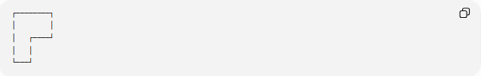
┌────────┐
│ │
│ ┌────┘
│ │
└───┘
The recessed part:
┌────
│
is the inward indentation.
In geometry, an inward indentation creates a reflex interior angle:
$$\boxed{{270}^{∘}}$$
So:
$$\boxed{\text{Inward indentation}→\text{Reflex angle}→\text{Concave shape}}$$
Opposite term
The opposite is an outward protrusion — a part of the shape that extends outward.
Inward indentation = recessed/notched part of a shape.
Would you like a simple real-world example of an inward indentation?

Fundamental Concept
# Source: AI Source: Provided by: [Data Path: Persons Table -> ID Column: 1, Name_En Column: Motasem Essam] -> From: [ChatGPT] on [7/25/2026]
A rectilinear shape has a boundary made only from horizontal and vertical line segments.
When the boundary contains an inward turn, the corresponding interior angle becomes a reflex angle:
$$\boxed{{270}^{∘}}$$
This reflex angle is what makes the shape concave.
Example
An L-shaped region is a typical concave rectilinear shape:
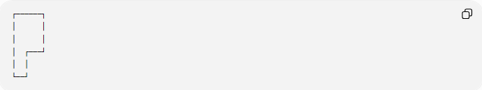
┌──────┐
│ │
│ │
│ ┌───┘
│ │
└──┘
The inward corner has an interior angle of:
$${270}^{∘}$$

Main Characteristics
# Source: AI Source: Provided by: [Data Path: Persons Table -> ID Column: 1, Name_En Column: Motasem Essam] -> From: [ChatGPT] on [7/25/2026]
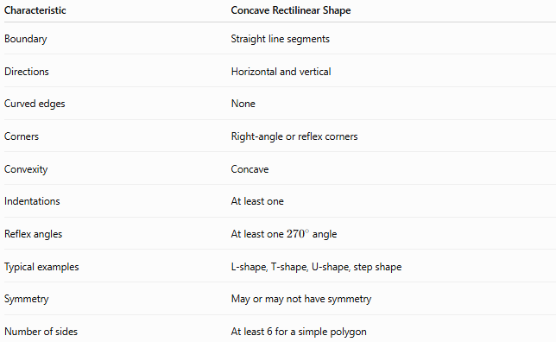
Characteristic | Concave Rectilinear Shape
Boundary | Straight line segments
Directions | Horizontal and vertical
Curved edges | None
Corners | Right-angle or reflex corners
Convexity | Concave
Indentations | At least one
Reflex angles | At least one ${270}^{∘}$angle
Typical examples | L-shape, T-shape, U-shape, step shape
Symmetry | May or may not have symmetry
Number of sides | At least 6 for a simple polygon

Interior Angles
# Source: AI Source: Provided by: [Data Path: Persons Table -> ID Column: 1, Name_En Column: Motasem Essam] -> From: [ChatGPT] on [7/25/2026]
For a simple rectilinear polygon, every interior angle is either:
$${90}^{∘}$$
or
$${270}^{∘}$$
A convex corner has:
$${90}^{∘}$$
A concave or reflex corner has:
$${270}^{∘}$$
Example
An L-shaped rectilinear polygon may have:
- several ${90}^{∘}$angles
- one or more ${270}^{∘}$angles
The presence of even one ${270}^{∘}$interior angle makes the polygon concave.

Minimum Number of Sides
# Source: AI Source: Provided by: [Data Path: Persons Table -> ID Column: 1, Name_En Column: Motasem Essam] -> From: [ChatGPT] on [7/25/2026]
A simple concave rectilinear polygon must have at least 6 sides.
The smallest common example is the L-shaped polygon.
Why not 5 sides?
A rectilinear polygon must alternate between horizontal and vertical directions, so a simple closed rectilinear polygon must have an even number of sides.
Thus:
$$n=4,6,8,10,…$$
Since a 4-sided rectilinear polygon is a rectangle and is convex, the smallest concave case is:
$$\boxed{n=6}$$

Relationship Between Convex and Reflex Vertices
# Source: AI Source: Provided by: [Data Path: Persons Table -> ID Column: 1, Name_En Column: Motasem Essam] -> From: [ChatGPT] on [7/25/2026]
For a simple rectilinear polygon:
$$\boxed{C=R+4}$$
where:
- $C$= number of convex vertices
- $R$= number of reflex vertices
Since:
$$n=C+R$$
we obtain:
$$\boxed{n=2R+4}$$
Therefore:
$$\boxed{R=\frac{n-4}{2}}$$
Examples
For a 6-sided rectilinear polygon:
$$R=\frac{6-4}{2}=1$$
So it has:
- 5 convex ${90}^{∘}$vertices
- 1 reflex ${270}^{∘}$vertex
For an 8-sided rectilinear polygon:
$$R=\frac{8-4}{2}=2$$
So it has:
- 6 convex vertices
- 2 reflex vertices

Classification of Concave Rectilinear Shapes
# Source: AI Source: Provided by: [Data Path: Persons Table -> ID Column: 1, Name_En Column: Motasem Essam] -> From: [ChatGPT] on [7/25/2026]
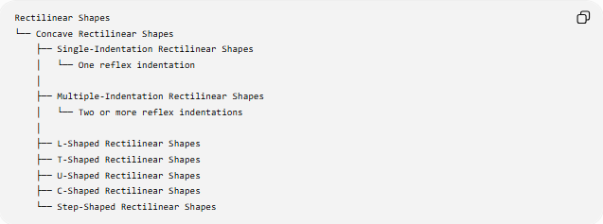
Rectilinear Shapes
└── Concave Rectilinear Shapes
├── Single-Indentation Rectilinear Shapes
│ └── One reflex indentation
│
├── Multiple-Indentation Rectilinear Shapes
│ └── Two or more reflex indentations
│
├── L-Shaped Rectilinear Shapes
├── T-Shaped Rectilinear Shapes
├── U-Shaped Rectilinear Shapes
├── C-Shaped Rectilinear Shapes
└── Step-Shaped Rectilinear Shapes
These names are mainly descriptive classifications based on the visual arrangement of the boundary.

Common Examples
# Source: AI Source: Provided by: [Data Path: Persons Table -> ID Column: 1, Name_En Column: Motasem Essam] -> From: [ChatGPT] on [7/25/2026]
L-Shaped Rectilinear Shape
A region formed by removing a rectangular portion from a corner of a rectangle.
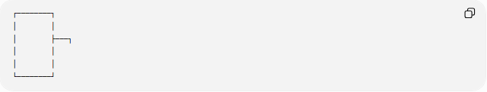
┌────────┐
│ │
│ ├───┐
│ │
│ │
└────────┘
It normally has one reflex vertex.

T-Shaped Rectilinear Shape
A rectilinear region resembling the letter T.
It contains inward corners where the vertical and horizontal portions meet.

U-Shaped Rectilinear Shape
A region with a central inward indentation.

┌───┐ ┌───┐
│ │ │ │
│ └───┘ │
│ │
└───────────┘
A U-shape contains multiple reflex vertices.

C-Shaped Rectilinear Shape
A rectilinear region resembling the letter C, with an opening and inward boundary structure.

Step-Shaped Rectilinear Shape
A shape whose boundary contains a sequence of rectangular steps.
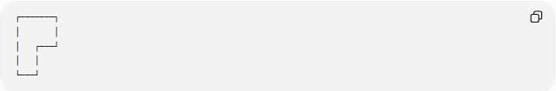
┌───────┐
│ │
│ ┌───┘
│ │
└───┘
Depending on its structure, it can have multiple reflex vertices.

Area of a Concave Rectilinear Shape
# Source: AI Source: Provided by: [Data Path: Persons Table -> ID Column: 1, Name_En Column: Motasem Essam] -> From: [ChatGPT] on [7/25/2026]
The area can usually be calculated by decomposing the shape into rectangles.
Method 1: Addition
Divide the shape into non-overlapping rectangles:
$$A=A_{1}+A_{2}+⋯+A_{n}$$
Method 2: Subtraction
Start with a larger enclosing rectangle and subtract the missing rectangular portions:
$$\boxed{A=A_{\text{outer}}-A_{\text{removed}}}$$
This is especially useful for L-shaped, U-shaped, and step-shaped regions.

Perimeter
# Source: AI Source: Provided by: [Data Path: Persons Table -> ID Column: 1, Name_En Column: Motasem Essam] -> From: [ChatGPT] on [7/25/2026]
The perimeter is the total length of all boundary segments:
$$\boxed{P=l_{1}+l_{2}+⋯+l_{n}}$$
Even though the shape is concave, its perimeter is still found by adding every boundary segment.
For a closed rectilinear shape:
$$\text{Total horizontal length right}=\text{Total horizontal length left}$$
and
$$\text{Total vertical length up}=\text{Total vertical length down}$$
These relationships can be used to determine unknown side lengths.

Convex vs. Concave Rectilinear Shapes
# Source: AI Source: Provided by: [Data Path: Persons Table -> ID Column: 1, Name_En Column: Motasem Essam] -> From: [ChatGPT] on [7/25/2026]
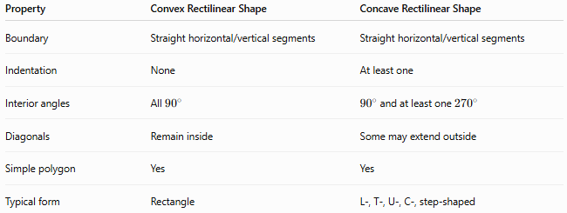
Property | Convex Rectilinear Shape | Concave Rectilinear Shape
Boundary | Straight horizontal/vertical segments | Straight horizontal/vertical segments
Indentation | None | At least one
Interior angles | All ${90}^{∘}$ | ${90}^{∘}$and at least one ${270}^{∘}$
Diagonals | Remain inside | Some may extend outside
Simple polygon | Yes | Yes
Typical form | Rectangle | L-, T-, U-, C-, step-shaped
Important mathematical fact
A simple convex rectilinear polygon is necessarily a rectangle.
Therefore, non-rectangular simple rectilinear polygons are concave.
For example:
$$\boxed{\text{Rectangle}→\text{Convex Rectilinear}}$$
while:
$$\boxed{\text{L-shape}→\text{Concave Rectilinear}}$$

Concave Rectilinear Shape vs. Irregular Shape
# Source: AI Source: Provided by: [Data Path: Persons Table -> ID Column: 1, Name_En Column: Motasem Essam] -> From: [ChatGPT] on [7/25/2026]
These terms describe different properties.
Concave Rectilinear Shape
Describes:
- the type of boundary: rectilinear
- the geometric property: concave
Irregular Shape
Describes a lack of regularity or equality.
A shape can therefore be:
- concave and regular in some limited visual sense,
- concave and irregular,
- symmetric and concave,
- asymmetric and concave.
Thus:
$$\boxed{\text{Concave}≠\text{Irregular}}$$

Concave Rectilinear Shape vs. Freeform Shape
# Source: AI Source: Provided by: [Data Path: Persons Table -> ID Column: 1, Name_En Column: Motasem Essam] -> From: [ChatGPT] on [7/25/2026]
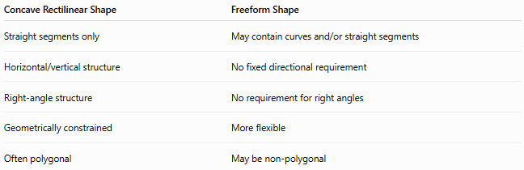
Concave Rectilinear Shape | Freeform Shape
Straight segments only | May contain curves and/or straight segments
Horizontal/vertical structure | No fixed directional requirement
Right-angle structure | No requirement for right angles
Geometrically constrained | More flexible
Often polygonal | May be non-polygonal
An L-shaped region is concave rectilinear, while an irregular flowing organic boundary may be freeform.

Mathematical Classification Tree
# Source: AI Source: Provided by: [Data Path: Persons Table -> ID Column: 1, Name_En Column: Motasem Essam] -> From: [ChatGPT] on [7/25/2026]
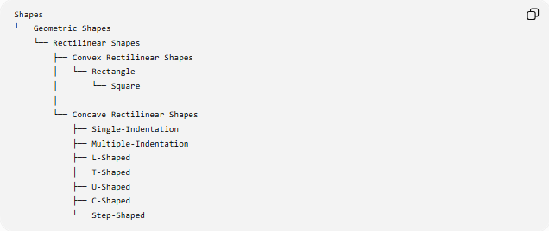
Shapes
└── Geometric Shapes
└── Rectilinear Shapes
├── Convex Rectilinear Shapes
│ └── Rectangle
│ └── Square
│
└── Concave Rectilinear Shapes
├── Single-Indentation
├── Multiple-Indentation
├── L-Shaped
├── T-Shaped
├── U-Shaped
├── C-Shaped
└── Step-Shaped
A more mathematical classification is:
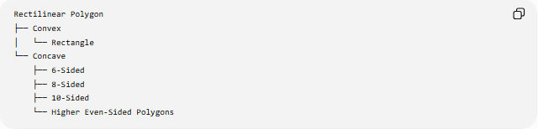
Rectilinear Polygon
├── Convex
│ └── Rectangle
└── Concave
├── 6-Sided
├── 8-Sided
├── 10-Sided
└── Higher Even-Sided Polygons

Key Properties
# Source: AI Source: Provided by: [Data Path: Persons Table -> ID Column: 1, Name_En Column: Motasem Essam] -> From: [ChatGPT] on [7/25/2026]
For a simple concave rectilinear polygon:
$$\boxed{\text{All edges are horizontal or vertical}} \\ \boxed{\text{All interior angles are }{90}^{∘}\text{ or }{270}^{∘}} \\ \boxed{\text{At least one interior angle is }{270}^{∘}} \\ \boxed{n\text{ is even}} \\ \boxed{n≥6} \\ \boxed{R=\frac{n-4}{2}}$$
where $R$is the number of reflex vertices.

Example
# Source: AI Source: Provided by: [Data Path: Persons Table -> ID Column: 1, Name_En Column: Motasem Essam] -> From: [ChatGPT] on [7/25/2026]
Consider a simple L-shaped rectilinear polygon with 6 sides.
Its angle structure is:
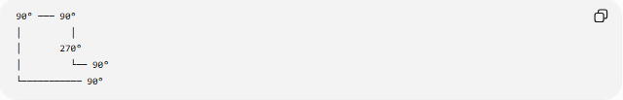
90° ─── 90°
│ │
│ 270°
│ └── 90°
└─────────── 90°
It has:
- $6$sides
- $6$vertices
- $5$convex vertices
- $1$reflex vertex
- one inward indentation
- only horizontal and vertical edges
The interior-angle sum is:
$$\left(6-2\right)×{180}^{∘}={720}^{∘}$$
and:
$$5\left({90}^{∘}\right)+1\left({270}^{∘}\right)={450}^{∘}+{270}^{∘}={720}^{∘}$$
which agrees with the polygon interior-angle formula.

Key Points
# Source: AI Source: Provided by: [Data Path: Persons Table -> ID Column: 1, Name_En Column: Motasem Essam] -> From: [ChatGPT] on [7/25/2026]
- A Concave Rectilinear Shape has only horizontal and vertical straight boundary segments.
- It contains at least one inward indentation.
- A simple concave rectilinear polygon has at least one ${270}^{∘}$reflex angle.
- Its number of sides is even and at least $6$.
- Common examples include L-, T-, U-, C-, and step-shaped regions.
- A simple convex rectilinear polygon can only be a rectangle; non-rectangular simple rectilinear polygons are concave.
- Its area can often be found by adding or subtracting rectangles.
- Concavity and irregularity are different concepts.

Conclusion
# Source: AI Source: Provided by: [Data Path: Persons Table -> ID Column: 1, Name_En Column: Motasem Essam] -> From: [ChatGPT] on [7/25/2026]
A Concave Rectilinear Shape is a closed shape with a boundary made entirely of horizontal and vertical line segments and with at least one inward indentation. In a simple polygonal case, this produces one or more ${270}^{∘}$reflex angles. L-shaped, T-shaped, U-shaped, C-shaped, and step-shaped regions are common examples.
$$\boxed{\text{Concave Rectilinear Shape}=\text{Rectilinear Shape + Concavity}}$$

